COMPUTER PROJECT

MADE BY-SOHEL AHMED AND SOHAM THODGE

XII-A

TOPIC: STENOGRAPHY AND ENCODE/DECODE

LIONS ENGLISH SCHOOL

SILVASSA

1)WHAT IS STENOGRAPHY?

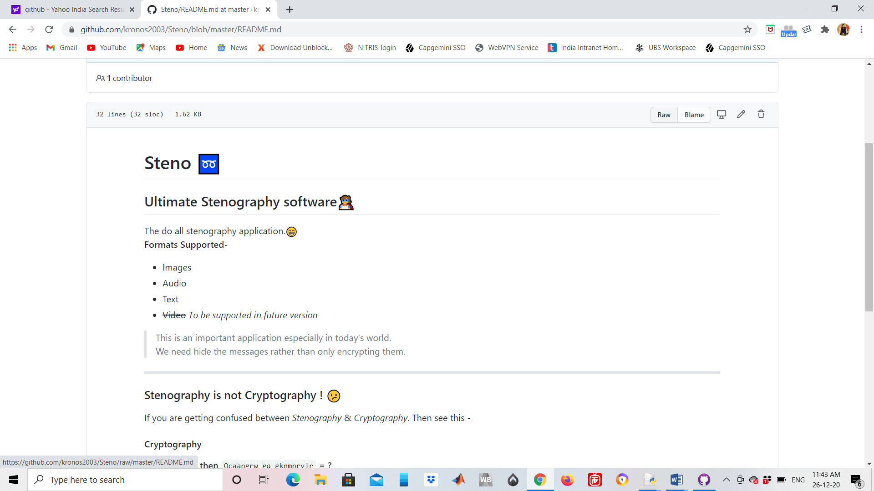

TO BE NOTED- Images support .png ,same goes with audio files supporting .wav, text files support .txt

SR NO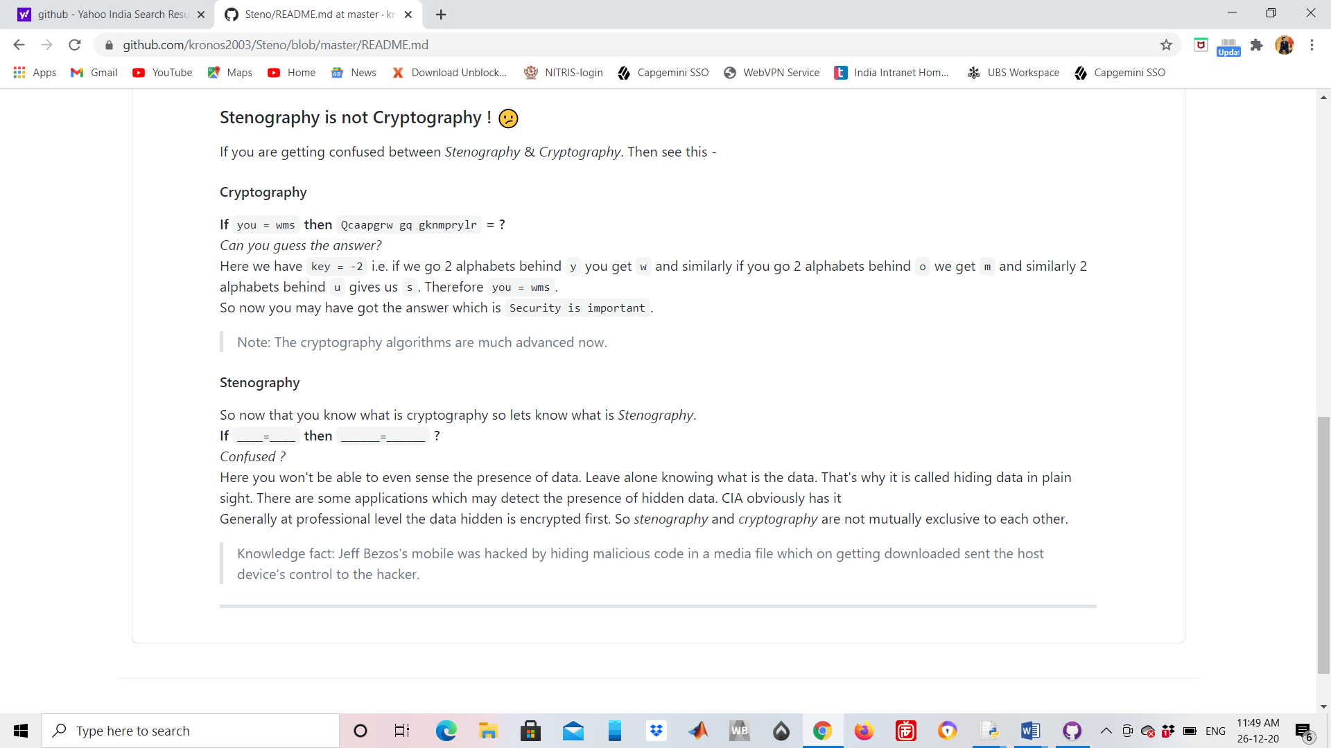

2)INDEX

|  |  |
| --- | --- |
| REFERENCE | CONTENT |
| A | A LOOK AT THE GUI |
| B | ALL STENOGRAPHY RESULTS |
| C |  |

A)A LOOK AT THE GUI

I)MAIN MENU

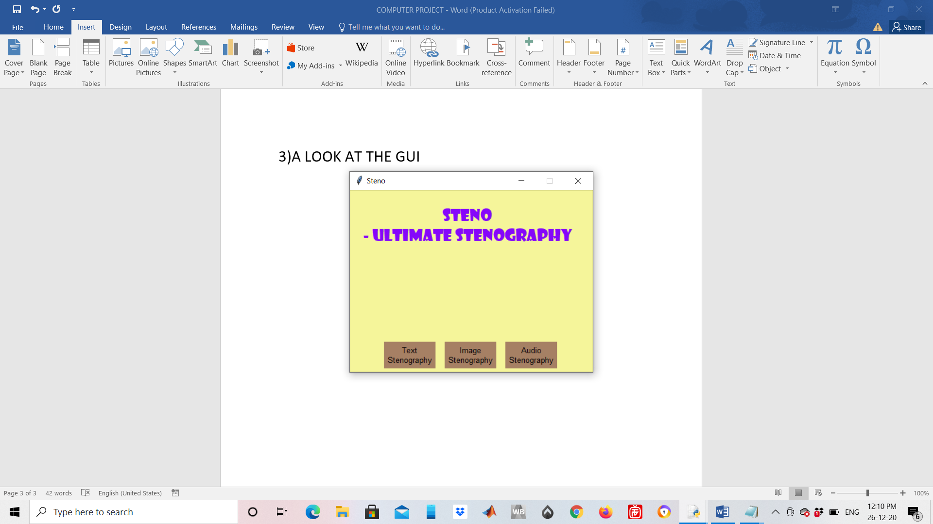

II)TEXT STENOGRAPHY

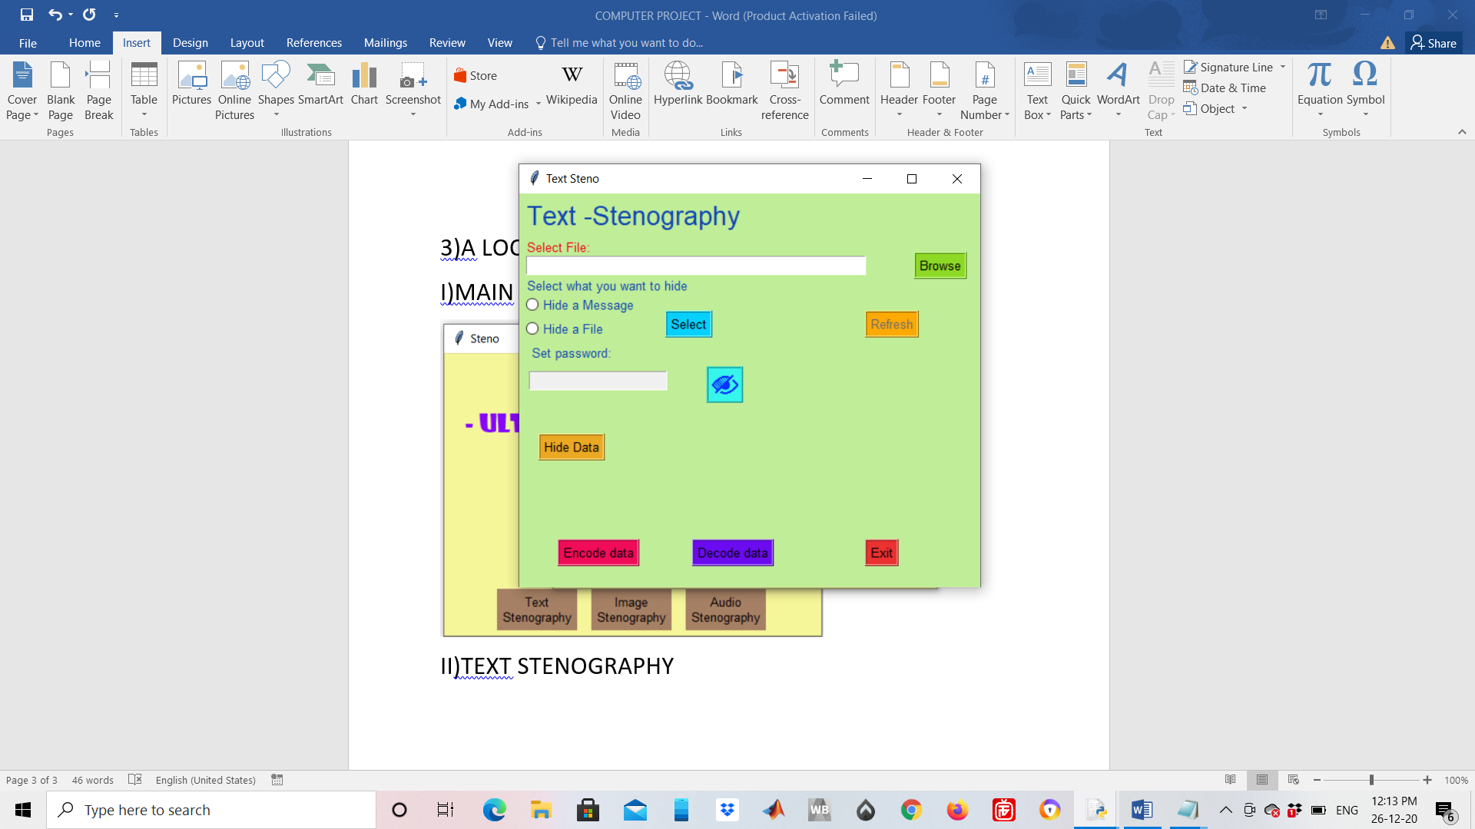

III)IMAGE STENOGRAPHY

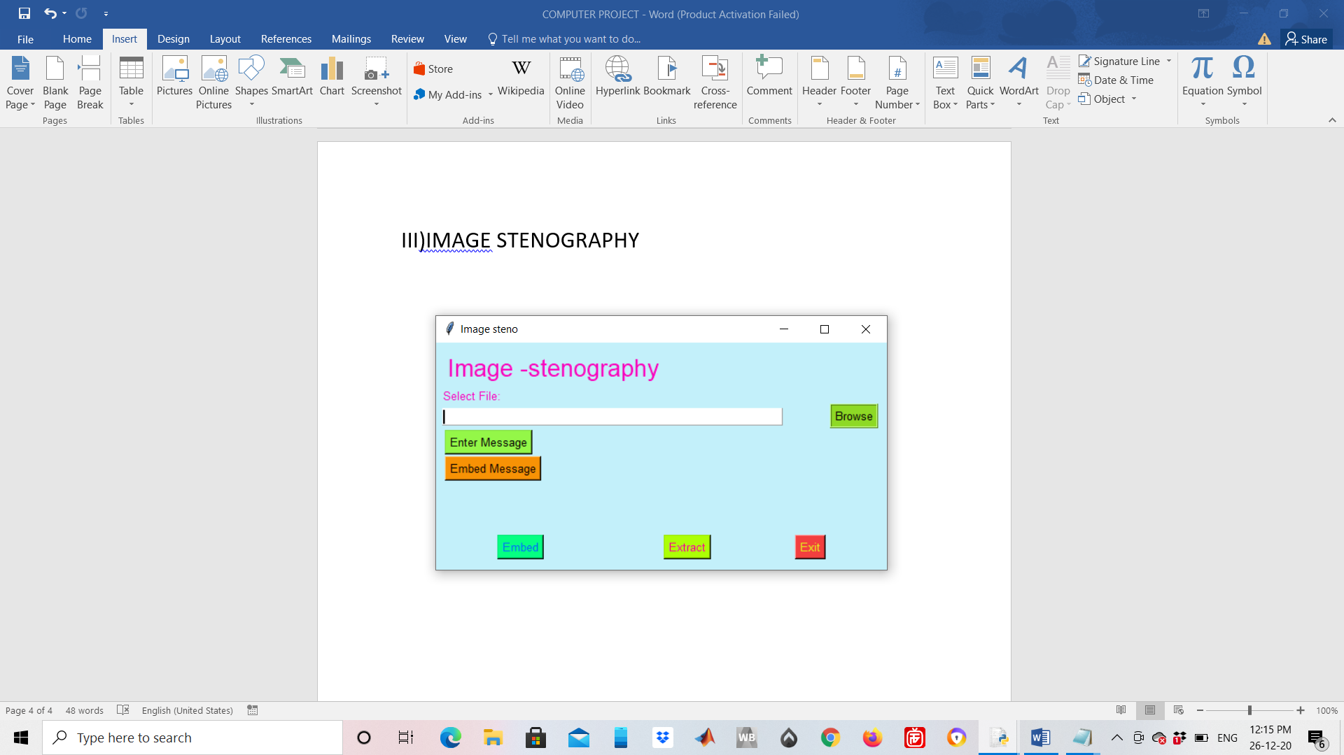

IV)AUDIO STENOGRAPHY

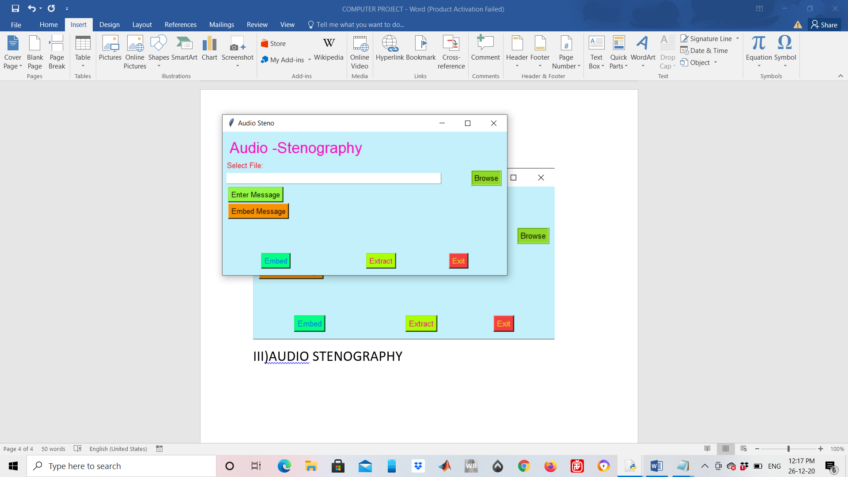

B)THE MAIN CODE AND MODULE LINKS

<main.py>

<image.py>

<hover.py>

<text.py>

<audio.py>

C) I)TEXT STENOGRAPHY

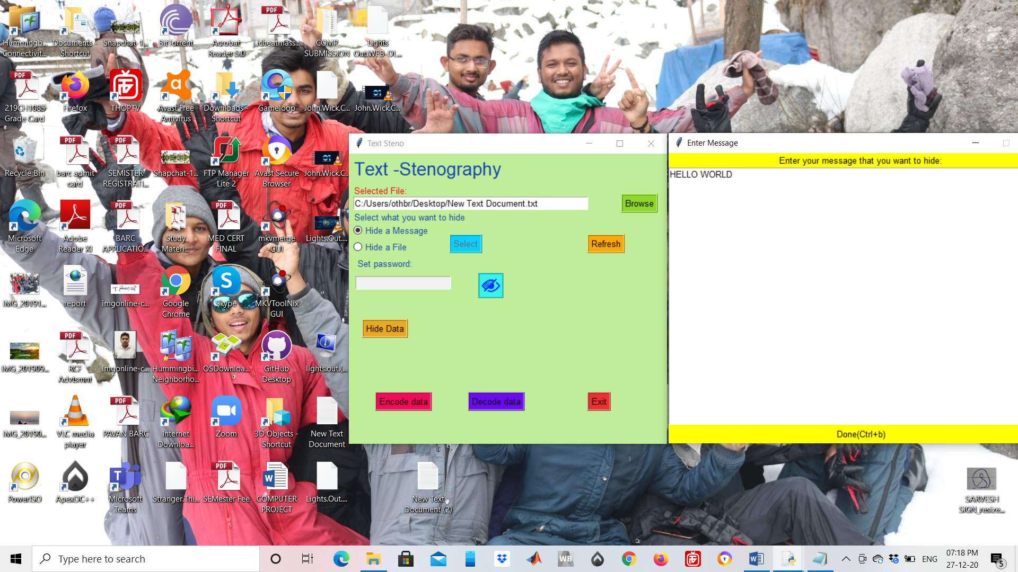

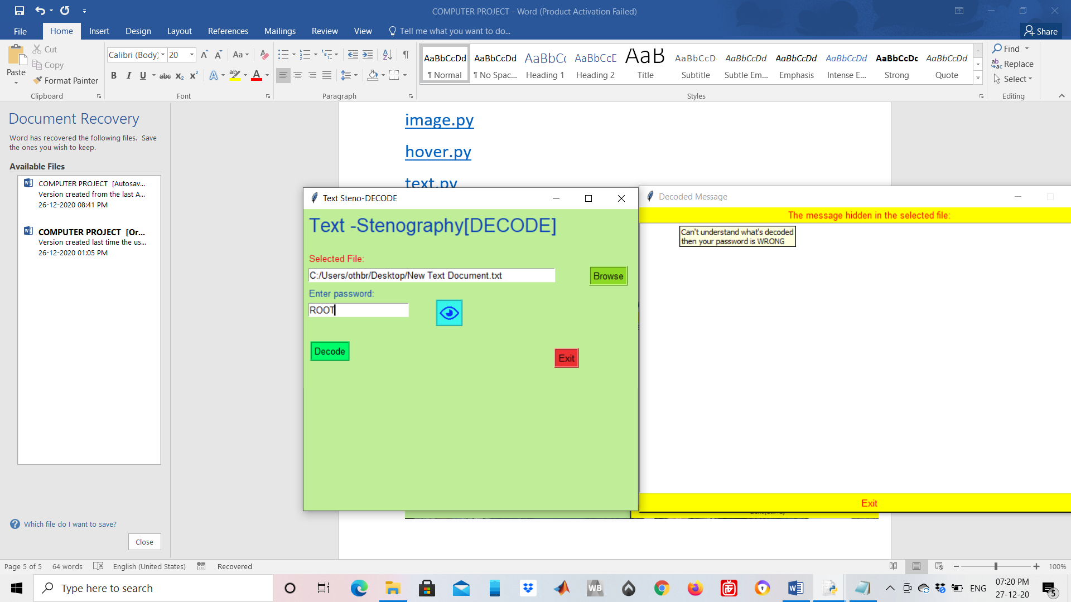

II)AUDIO STENOGRAPHY

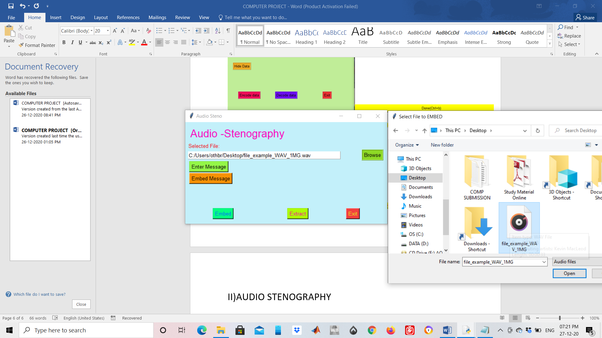

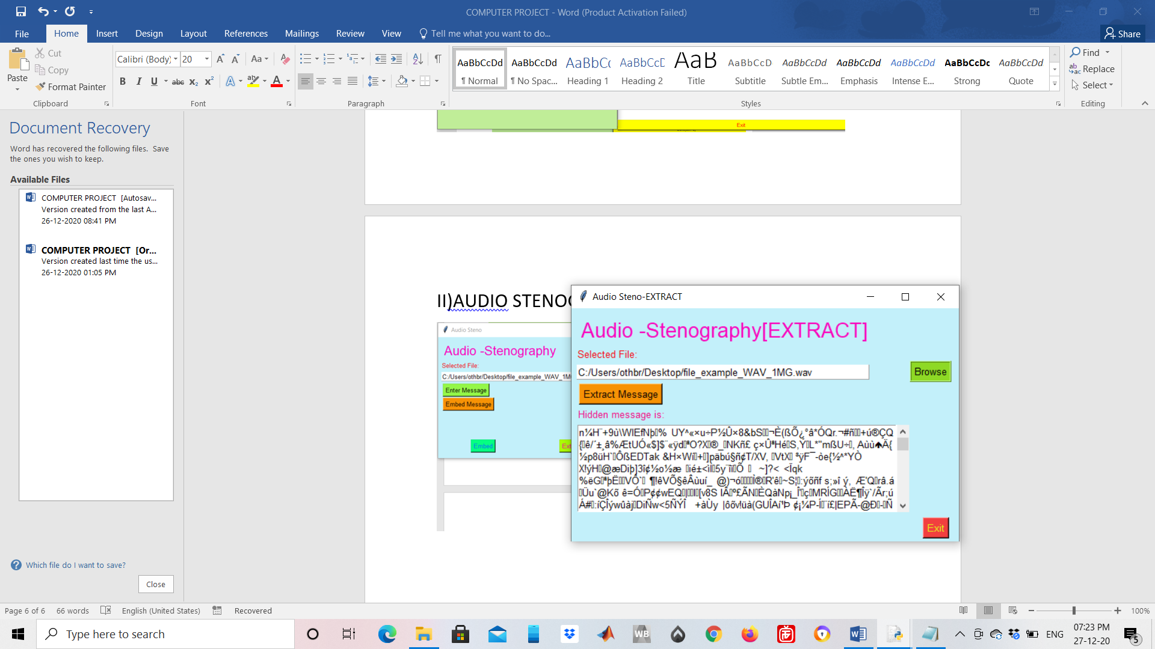

III)IMAGE STENOGRAPHY

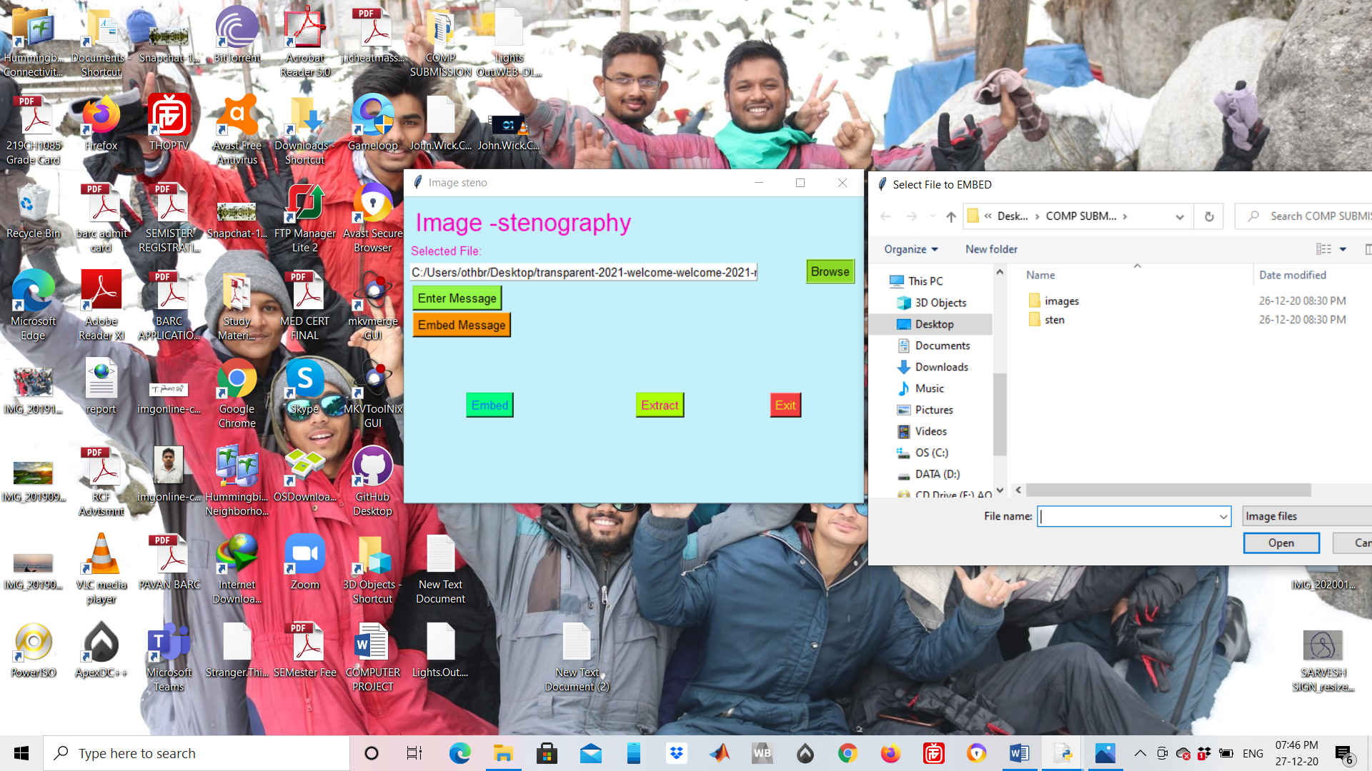

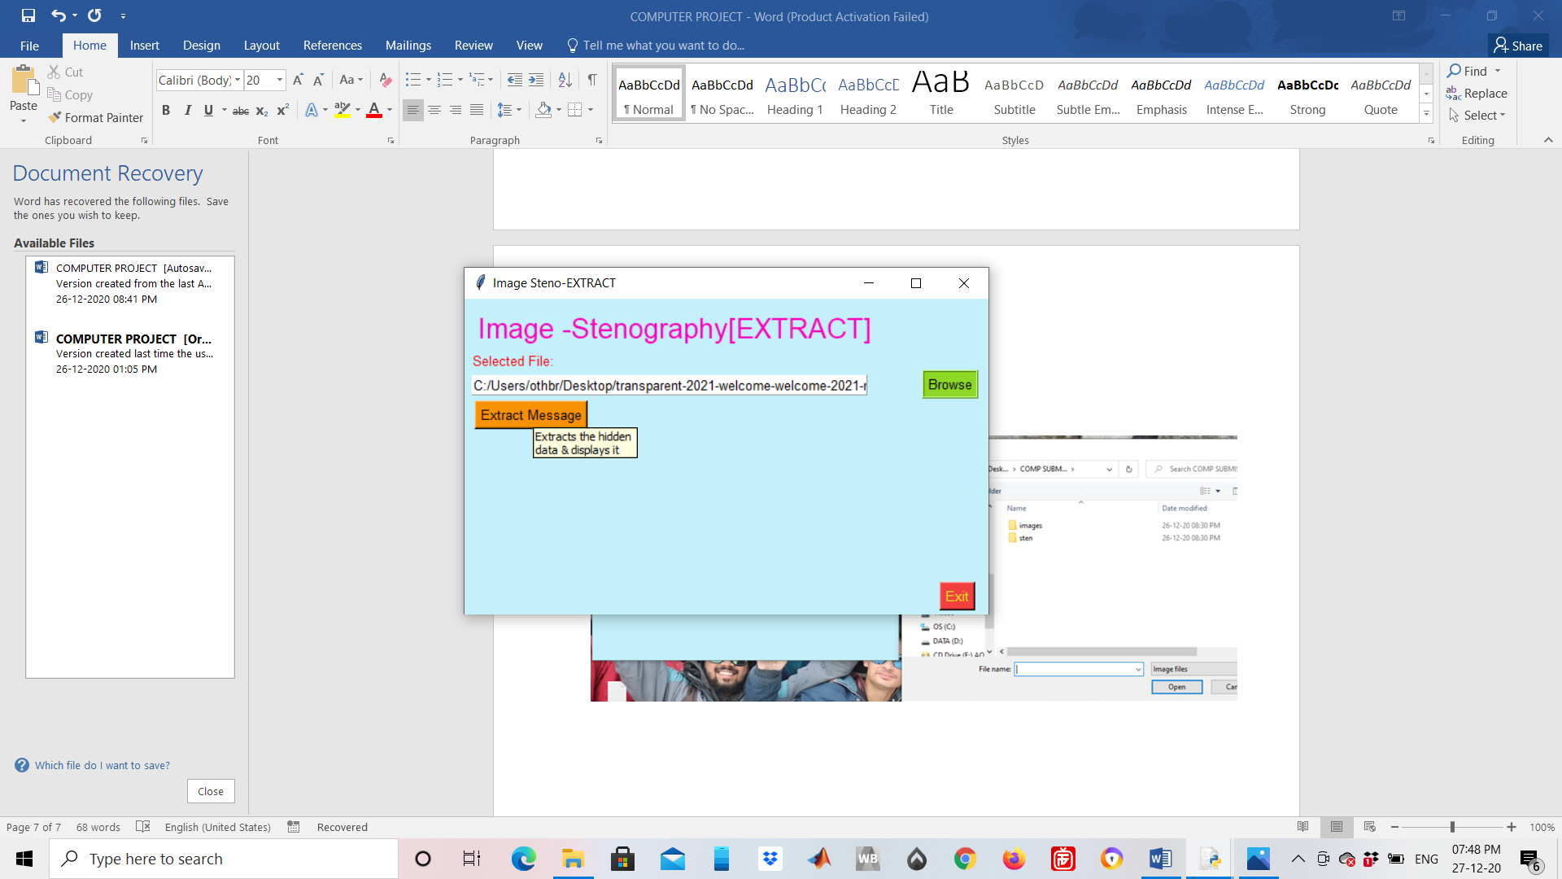

TO BE NOTED- THIS IS YET TO UNLOCK ITS FULL POTENTIAL AS IT ENCODES AND DECODES DATA IN ASCII AND UNICODE FORMAT BUT IT CAN EASILY USE IMAGES,AUDIO AND TEXT FOR STENOGRAPHY AND DATABASE HAS BEEN MADE AND CONNECTED USING SQL3 IN A DIFFERENT MODULE TO AVOID INTERFERENCE WITH THE MAIN CODE

3)CONCLUSION

ITS CLEAR THAT IT IS A NEW CONCEPT BUT ONE WORTH WORKING ON AS IN THE NEW AGE , DATA SECURTIY IS THE TOP MOST PRIORITY FOR MANY TECH FIRMS AND IT WILL HELP STRENGTHEN THE DATA SERVERS ACROSS THE WORLD TOO.WE THANK YOU FOR CHECKING OUR PROJECT OUT AND HOPE YOU LIKED IT. BELOW ARE THE ORGANIZATIONS THAT HELPED US COMPLETE IT.

Links-

[www.geeksforgeeks.org](http://www.geeksforgeeks.org)

various github code developers who helped us solve minor bugs

python libraries who provided us with some extra libraries important for conversions

THANK YOU